**AIR QUALITY MONITORING**

**Components need and Steps to Implement:**

1. *Hardware Setup*:

- Use sensors such as PM2.5, PM10, CO2, and VOC sensors to measure air quality parameters.

- Connect these sensors to a microcontroller (e.g., Arduino or Raspberry Pi) compatible with Tinkercad.

2. *Data Collection*:

- Collect data from the sensors at regular intervals.

- Use Tinkercad to simulate the hardware and data acquisition process if necessary.

3. *Data Transmission*:

- Implement Wi-Fi or Bluetooth connectivity to send the collected data to a cloud platform.

4. *Cloud Integration*:

- Utilize a cloud platform like AWS, Google Cloud, or Microsoft Azure to store and process the data.

- Create a dashboard to visualize the air quality data in real-time.

5. *Alerting System*:

- Set up threshold values for each air quality parameter.

- Implement an alerting system that sends notifications (e.g., email or SMS) when the air quality crosses predefined thresholds.

6. *User Interface*:

- Create a user-friendly interface for data visualization and control, which students can design using Tinkercad's interface.

7. *Battery Power*:

- Make the device portable by integrating a rechargeable battery and a power management system.

8. *Education Focus*:

- Emphasize the educational aspect by explaining the science behind air quality and the importance of monitoring it.

9. *Data Analysis*:

- Enable students to analyze historical air quality data to identify trends or correlations.

10. *Documentation and Presentation*:

- Encourage students to document their project with schematics, code, and a presentation that highlights the project's significance and outcomes

**FIG: Air Quality monitoring design**

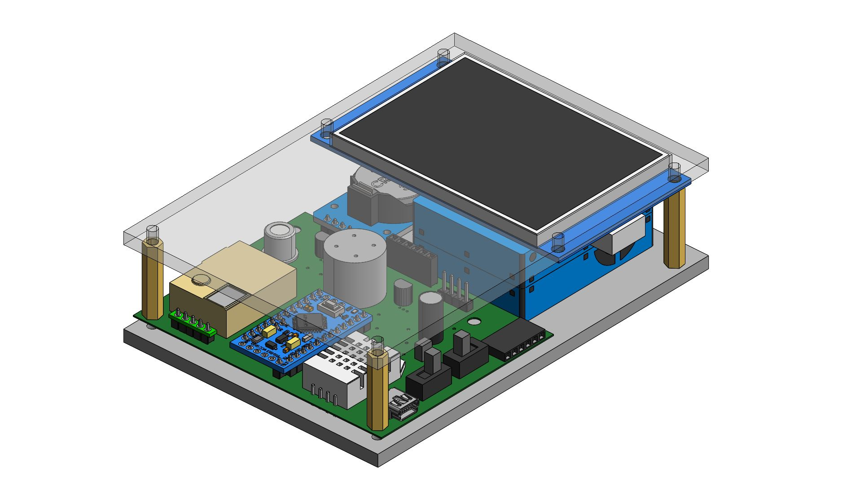

.

**Fig ; Air Quality Monitoring Sensors With Circuit**

